**Abstract**

Existing theories describing faceted growth and ablation of ice crystals have significant limitations in terms of the connection to the underlying physical processes. In filling that knowledge gap, the present model provides insights and predictive power about faceted growth and ablation that have not been possible previously. For example, the model exhibits Turing-like pattern behavior, in the sense that the horizontal distance between successive ice layers atop a growing facet is predicted to will increase in proportion to the square root of the surface diffusivity, consistent with a slight concavity observable in scanning electron images of growing facets.

1. **Prior theories of faceted ice crystal growth and ablation**

The BCF picture is clearly wrong between 240 K and melting, in that it assumes deposition atop a crystalline surface, whereas in reality the surface of real ice is covered by a quasi-liquid layer (QLL) whose efficiency at capturing incoming water vapor molecules is close to 100%.

The quasi-liquid continuum model introduced by some of the authors in 2016 (N2016) recasts the problem as an ice surface described by two mesoscale variables which interact with one another, and with the overlying vapor field (see Fig. 1). Variable represents the total thickness of the ice surface, while variable represents the thickness of just the quasi-liquid part of . A third may be computed from these: . Key atomistic processes incorporated in N2016 were: (i) vapor deposition and ablation, (ii) surface diffusion of the quasi-liquid across the facet, and (iii) conversion of quasi-liquid into ice, and vice versa.

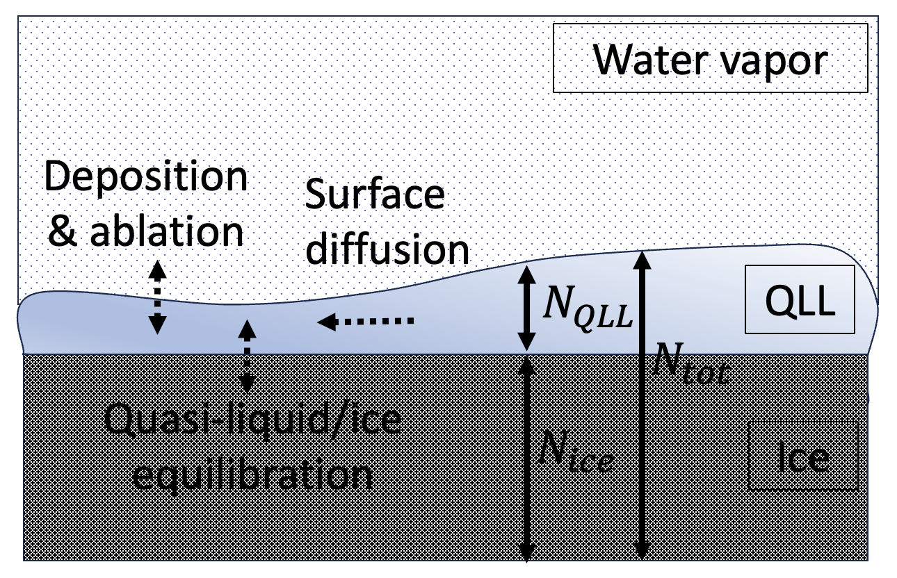

**Fig. 1**. Visual representation of mesoscale variables , , and , and processes affecting them, in the N2016 (and present) model. Dashed arrows represent processes affecting how these variables evolve over time.

A key accomplishment of the N2016 model is that model runs (“trajectories”) exhibited both unbound growth at facet corners (i.e., dendritic growth associated with snowflake formation), as well as faceted growth (a pattern of steady-state growth across the entire facet associated with hexagonal ice crystals found in cirrus clouds). The mechanism by which the latter occurred was termed “diffusive slowdown,” in which excess deposition of water vapor at facet corners is compensated by an emergent surface morphology change.

N2016 suffered from several limitations, however, of which the most important for our present purpose is that the time scale embedded in process (iii), the interconversion of quasi-liquid and ice, was fixed relative to processes (i) and (ii); in real crystal facets, this interconversion can be expected to act at a rate that is independent of those process, such as the nature of the underlying facet. The revised model corrects this deficiency, as described below.

1. **A revised quasi-liquid continuum model**

The model introduced here is defined by

(1a)

(1b)

Some notes about this model are as follows:

* 1. represents the idea that surface diffusion depends on the thickness of the quasi-liquid only; the underlying ice is considered immobile on time scales considered here.
  2. is the rate of exchange of water between the facet and the vapor phase (i.e. deposition and ablation).
  3. is the fractional difference between the rate of ablation and that of deposition (i.e., the surface supersaturation), given by …
  4. defines the thickness of quasi-liquid when it is in equilibrium with the underlying ice. Here (as in N2016) we use the sinusoidal form

(2)

* 1. is a first-order relaxation constant describing the time scale at which quasi-liquid/ice equilibrium is achieved. That is, if we imagine an initial situation having an amount of quasi-liquid given by , then equilibration after a time occurs according to

(3)

If one takes the time derivative of Eq. (3), and assumes that is small, the second term on the right-hand side of Eq. (1b) results.

The difference between the present model and N2016 therefore lies in the treatment of the quasi-liquid equilibration just described, i.e., the use of Eq. (1b) rather than Eq. (5b) of N2016. With this revision, we are able to parameterize the rate of quasi-liquid/ice equilibration relative to processes (i) and (ii). Specifying a small value for would conform to the idea that quasi-liquid/ice equilibration is fast compared to diffusion and exchanges with the vapor phase, while large would mean quasi-liquid/ice equilibration is fast compared to those processes.

We do not have reliable independent guides for determining , but we do have a guidepost: because the “diffusive slowdown” mechanism for stabilization of faceted ice growth described in N2016 required that quasi-liquid/ice equilibration be slow compared to surface diffusion, we should not be surprised if we find that large leads to stable growth scenarios. We return to this topic presently.

1. **The premise of this paper**

The premise of this paper is to explore predictions of the model embodied by Eqs. (1a-b), hand in hand with observations made of growing and ablating hexagonal ice crystals at the mesoscale in a scanning electron microscope. Questions we hope to explore are:

1. Although faceted surfaces appear flat on a mesoscale, SEM imagery we present here shows that they are in fact slightly concave. Is that concavity consistent with the model, and if so, what can we learn from it?
2. Is there such a thing as faceted ablation, and if so, does the model support such a phenomenon?
3. A key observed property of ice crystals is the onset of differential growth rates of different facets – specifically prismatic and basal facets – as a function of temperature and humidity. Those differential growth rates, in turn, lead to atmospherically relevant geometries, such as plates and columns. What governs those differential growth rates?
4. What governs the transition of a faceted hexagonal ice crystal to dendritic forms characterizing snowflakes?
5. What governs the onset of facet roughness? More specifically, is there a difference between the roughness that appears under supersaturated conditions, vs subsaturated conditions, and if so, what does the model tell us about that difference?
6. **Implementation details**

Python, accelerated with Numby.

1. **Results**

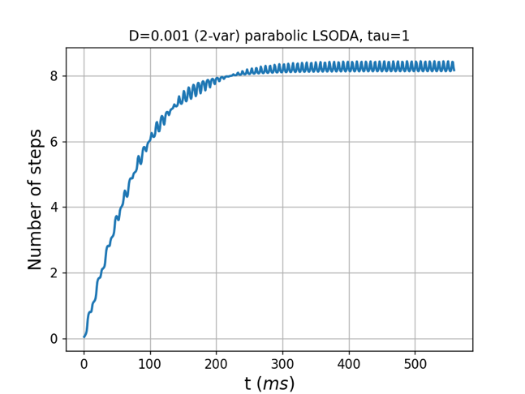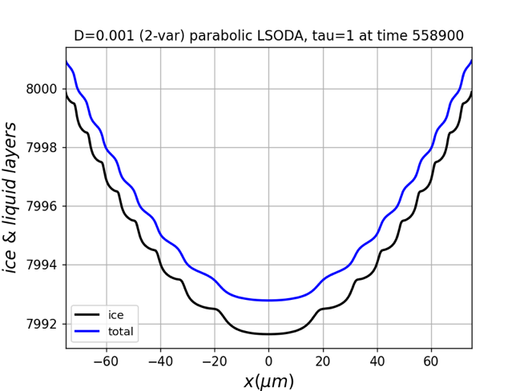

**Fig. 2**. Stabilization of faceted growth.

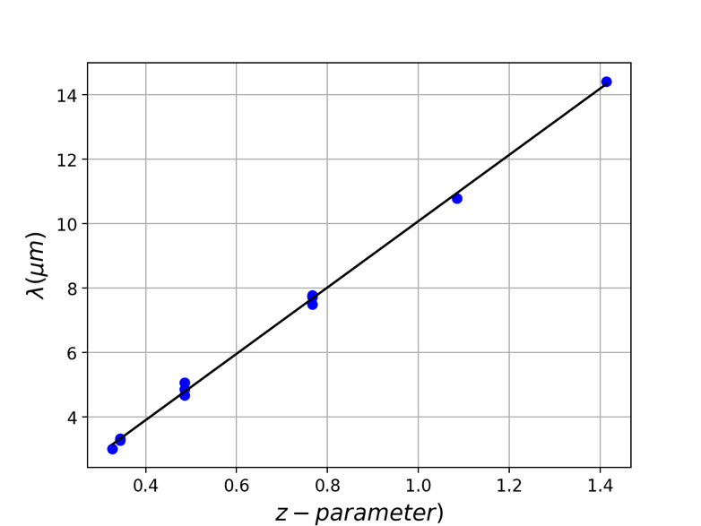

**Fig. 3**. Surface layer wavelength () as a function of parameter for a range of values of , , and .

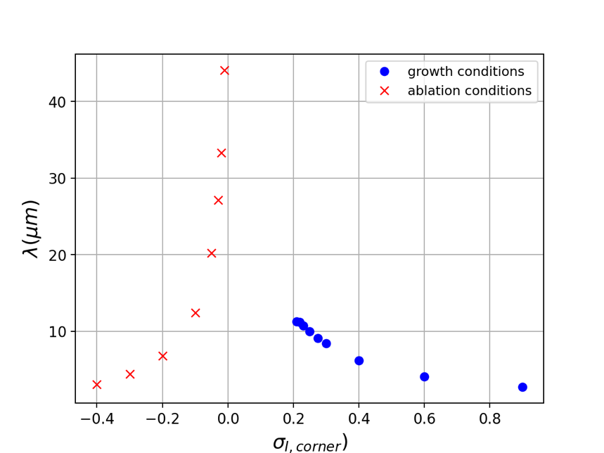

**Fig. 4**. Surface layer wavelength () as a function of corner supersaturation .